SE LAB -2
NAME :- HEMAVATHI E
SRN:- PES2UG24CS193
SECTION :D

Jira backlog with Epics and User Stories.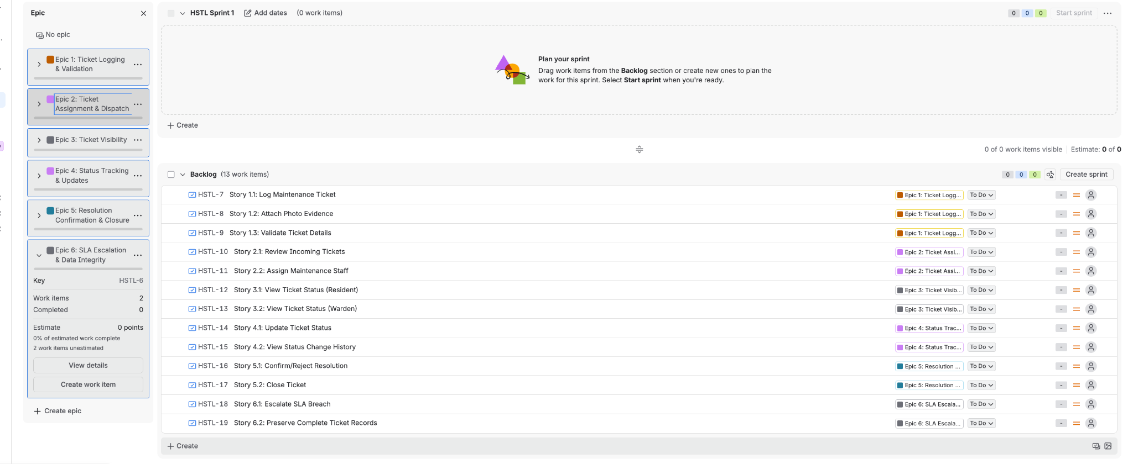
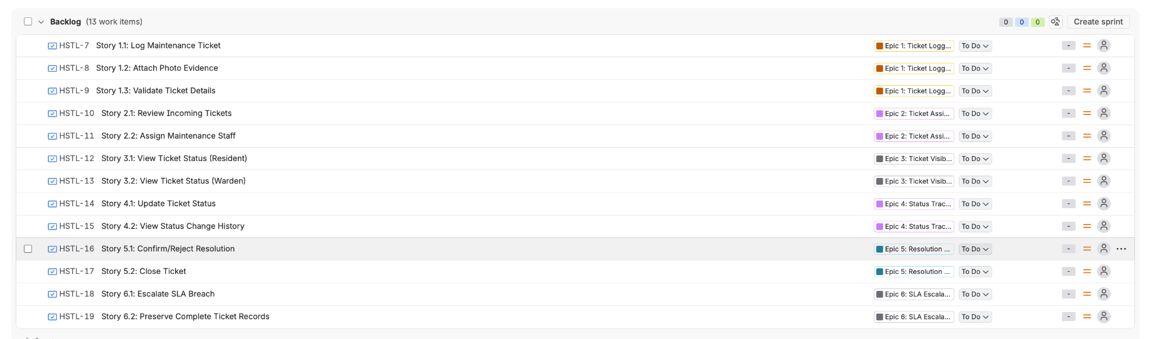
Story point assignments.

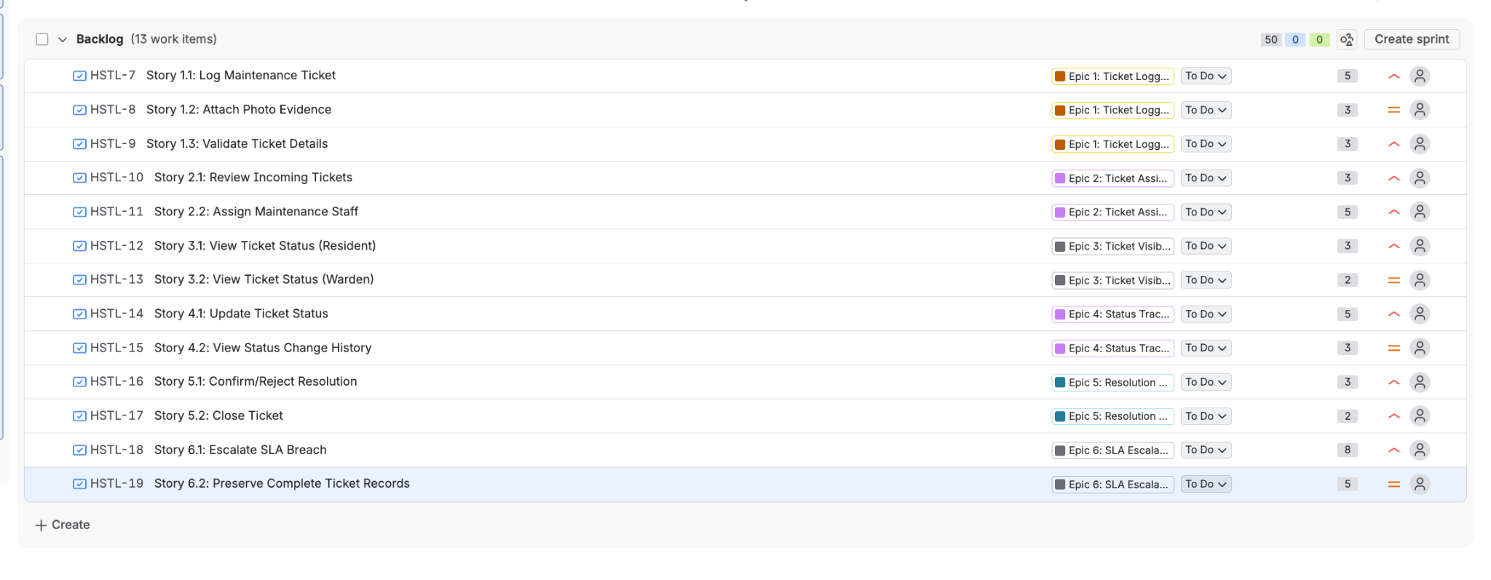
Sprint board (Active Sprint view).
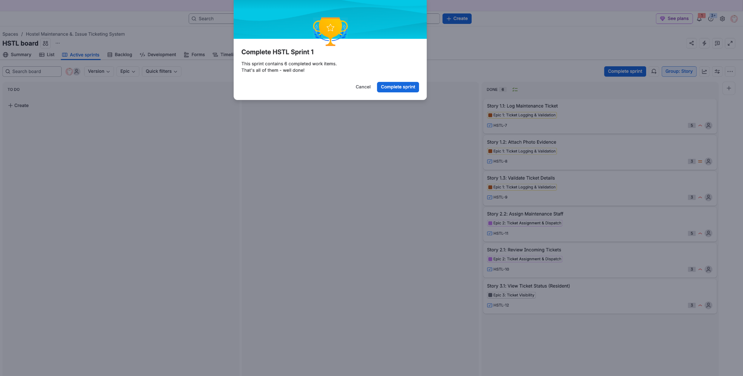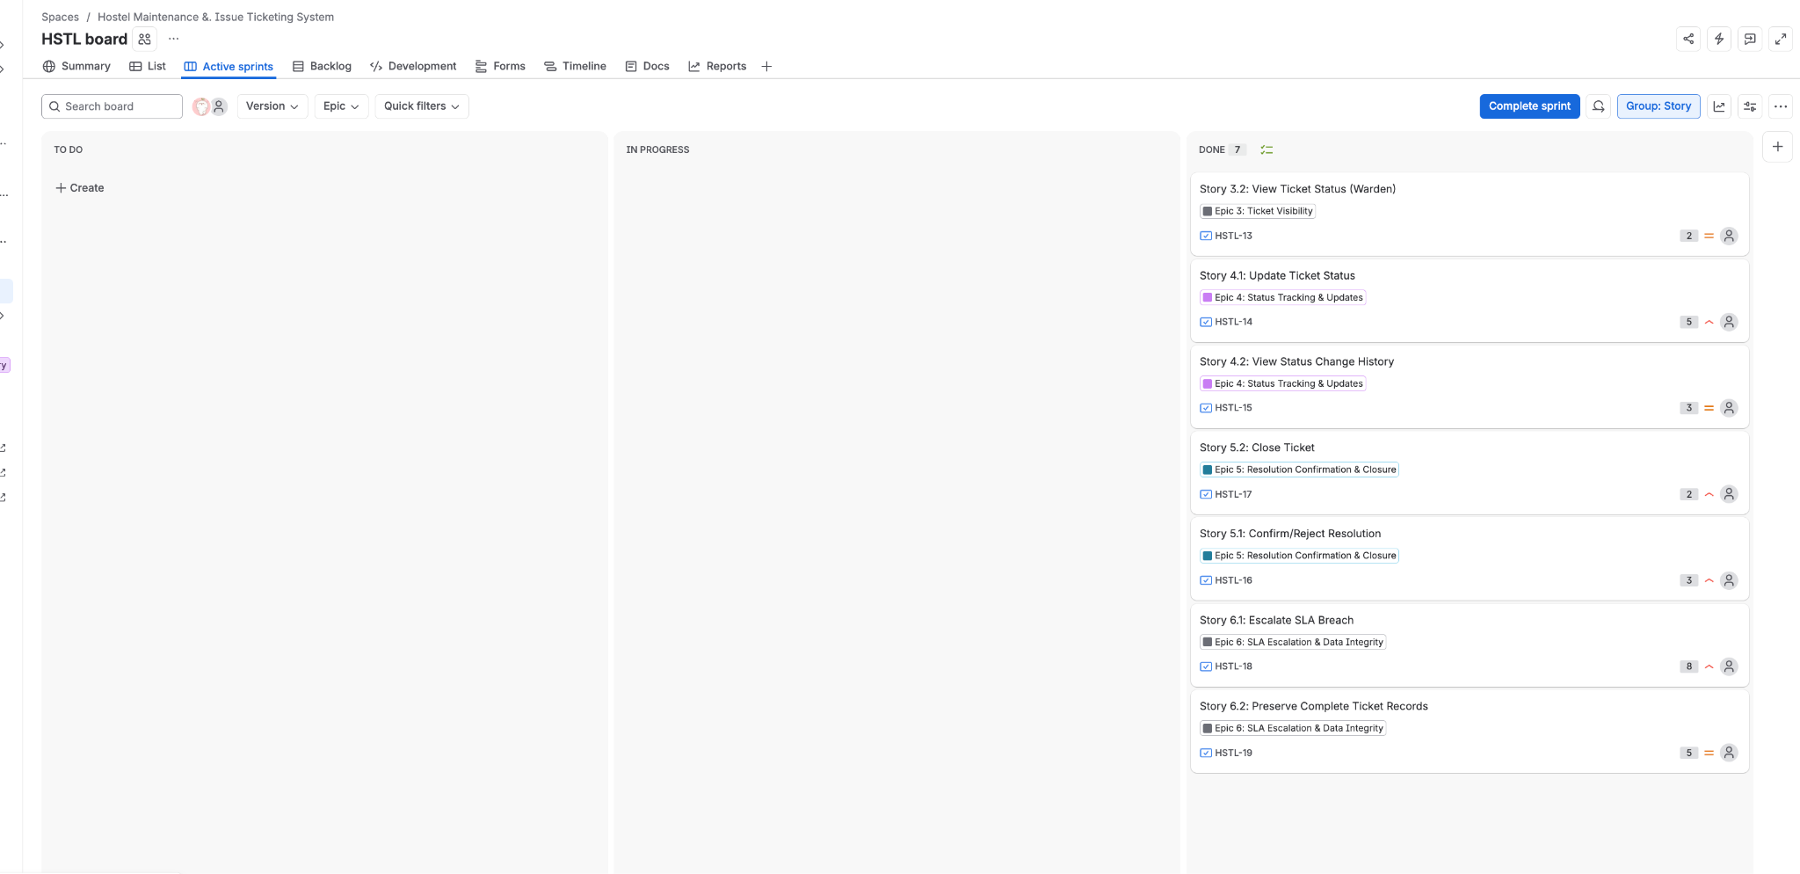
Burndown Chart.
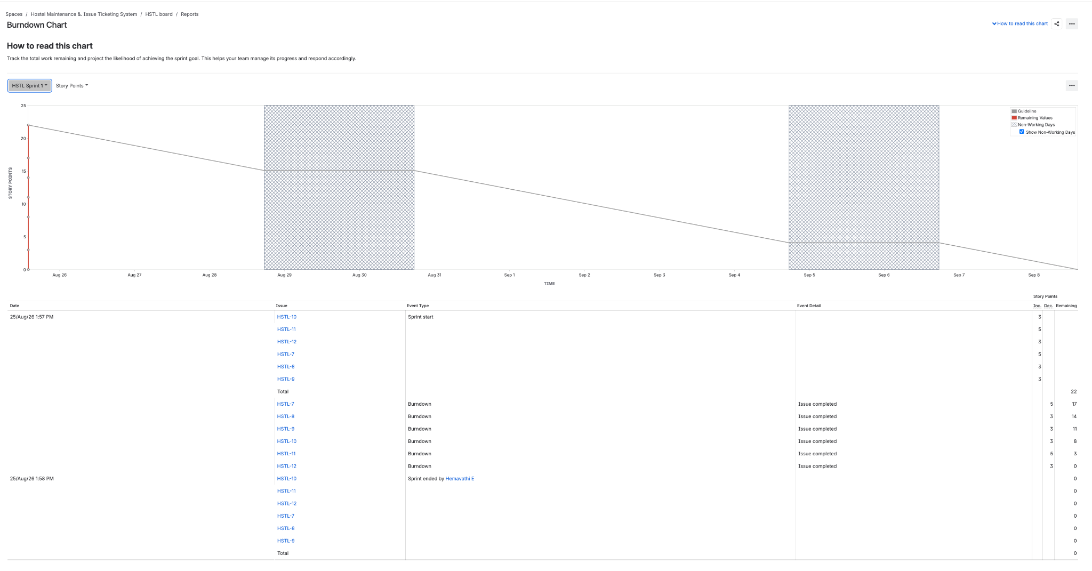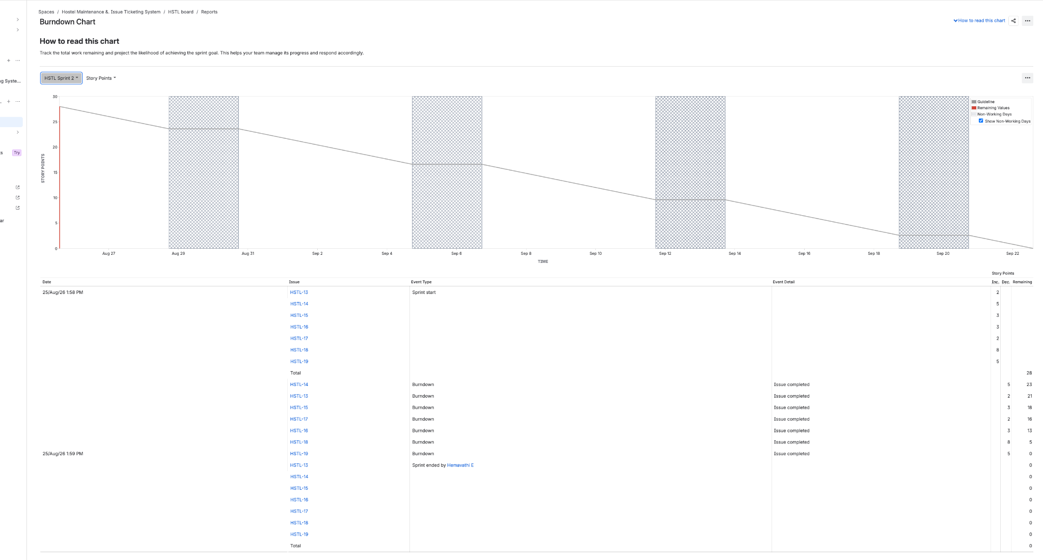

Reflection Questions:
1. Did your estimations reflect the actual effort?
Story points were assigned using the Fibonacci scale (2, 3, 5, 8) based on perceived complexity — e.g., "Log Maintenance Ticket" and "Assign Maintenance Staff" were rated higher (5 pts) due to multiple sub-requirements (room tagging, photo validation, assignment tracking), while simpler view/status stories were rated lower (2–3 pts). Since this was a simulated sprint rather than a real multi-day execution, the estimates were reasonable relative to each story's described complexity, but the actual effort couldn't be validated against real time spent — in a live sprint, "Escalate SLA Breach" (8 pts) would likely reveal itself as even more complex once notification/alerting logic is actually built, since it depends on time-triggered automation, which is inherently harder to estimate accurately upfront.

2. Was your backlog well-prioritized?
Yes — the backlog was ordered to follow the natural lifecycle of a ticket: logging and validation (Epic 1) came first, followed by assignment (Epic 2), visibility (Epic 3), status tracking (Epic 4), resolution/closure (Epic 5), and finally SLA escalation and data integrity (Epic 6). This ordering made sense because later epics (like closing a ticket or escalating a breach) logically depend on earlier ones (a ticket must exist and be assigned before it can be tracked or closed). High-priority stories tied to core FR requirements (FR-001 to FR-005) were sequenced ahead of the NFR-driven stories (Epic 6), which reflects sound business-value-first prioritization.

3. How did your simulated sprint align with your plan?
Both Sprint 1 and Sprint 2 completed all planned stories (6 items in Sprint 1, 7 items in Sprint 2), so on the surface the plan was fully executed. However, looking at the burndown chart, all stories were marked "Done" in a single batch near the point of sprint completion rather than being closed gradually across the week — this is a byproduct of the simulation (moving cards manually within minutes) rather than genuine day-by-day progress. In a real sprint, this pattern would be a red flag: it usually means work is being "batched" and reported late rather than continuously delivered.

4. What insights did the burndown chart give about your team’s capacity?
The burndown chart shows a sharp, near-vertical drop in remaining story points rather than a smooth diagonal decline toward zero. Ideally, the red "remaining work" line should track close to the grey guideline, showing steady day-over-day progress. Instead, the chart shows work remaining flat for most of the sprint before dropping all at once — this signals that either the team (in a real scenario) would be under-tracking daily progress, or that work was concentrated at the end rather than distributed across the sprint. This kind of pattern typically prompts a team to reassess whether tasks are being broken down finely enough, and whether status updates are happening in real time rather than in a last-minute push.

